Planning & Carrying Out Investigations Template
1. Materials. What do you need for your investigation? Resources, tools, and equipment:
Do you think you need other tools or materials? Develop a Materials List in consultation with your teacher.
2. Testable Question. What do you hope your experiment will reveal? Science question we will try to answer:

3. How will your investigation work? Experimental Set-up (Label equipment and materials used)

4. Experimental Steps (What we will do, listed in the order in which we will do it, and what we will measure or observe)

5. Expected Outcome (What we predict will happen)
Stop here, and check in with your teacher before proceeding!

6. Data & Observations:

7. What did your investigation reveal? What did you learn?
8. What new questions did this bring up?

Agricultural Plan Claim Template

Claim(s):
Evidence:
Calculations:
Assumptions:

Maps For Food Exploration
United States Map (Mark your location first!)
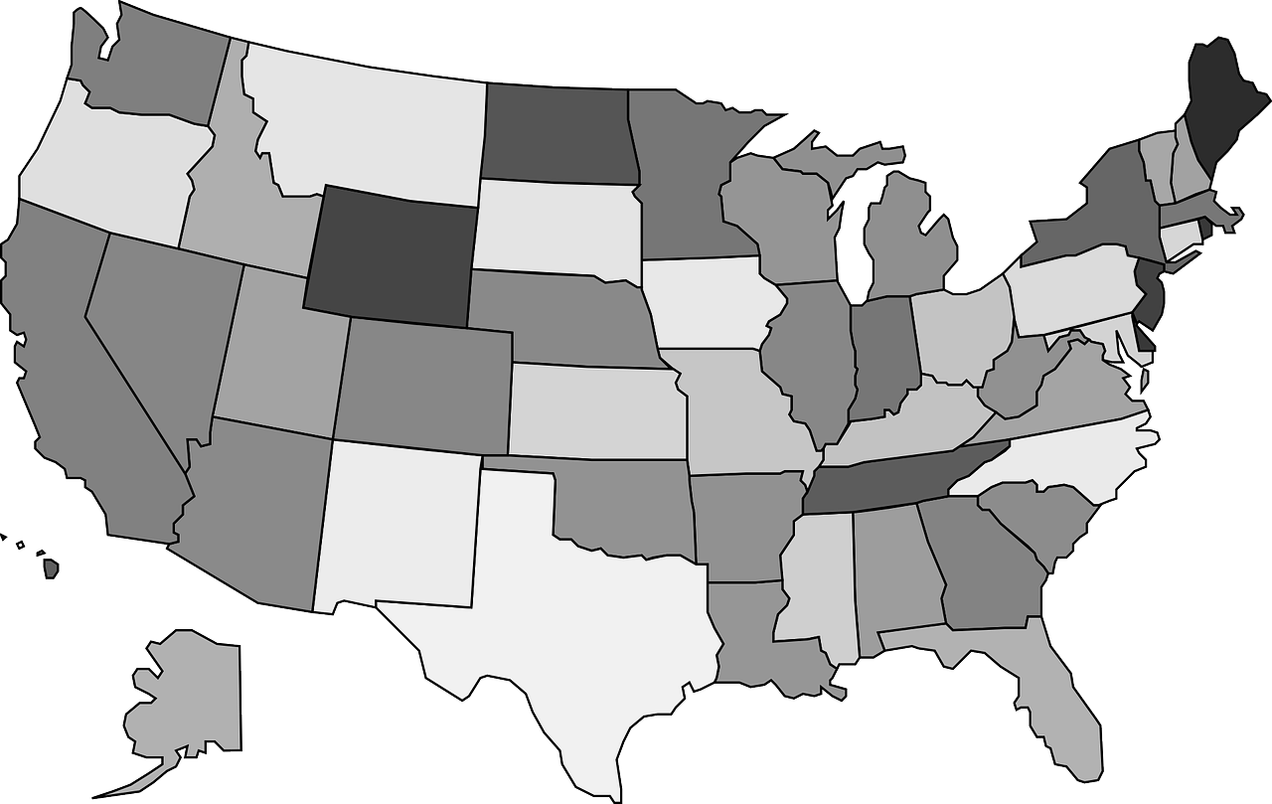

World Map
